School of Computing and Engineering | 
Assessment
Module: | Networks and Security (Level 5)
Module Code: | CP50088E (Full Time)
Assignment: | Networks and Security Report
Student: | Matheus Almeida
Student number: | 681679 - 33149385

Table of Content
Table of Content 1
Introduction 1
Project Scope 1
Objectives 1
Network Design & Documentation 2
Routing Protocol Configuration 3
Network Connectivity Verification 4
Security Policy Implementation 7
Potential Security Threats and Mitigation Strategies 8
Conclusion 10
Reflection on Learning Experience 10

Introduction
This report presents the design and security implementation of a multinational organisation. The project uses cisco packet tracer to design, configure, and test a secure network infrastructure across five distinct network zones.
The major goals for the project are as follows:
Designing a scalable network topology for enterprise network.
Designing a proper IP addressing scheme.
Configuring dynamic routing using two different routing protocols.
Ensuring connectivity between distributed sites.
Applying security policies to ensure that important resources are protected from any possible threat.
Analysis and recommendation for any possible threat that may be harmful to the network.
The main purpose is to build a network that facilitates communication and security at all Global Enterprises locations.

Project Scope
In the report outlines the design and implementation of a secure, scalable network infrastructure using cisco packet tracer. The project encompasses five critical segments: Headquarters (HQ), Branch Office 1 (BO1), Branch Office 2 (BO2), a centralized Data Center (DC), and a public-facing Demilitarized Zone (DMZ).

Objectives
My objectives are in network design I’ll create a hierarchical topology supporting seamless communication. Implement a structured IPv4 and VLAN scheme for efficient resource management. Configure dynamic routing (OSPF) to ensure high availability and optimal traffic flow. Apply robust security policies, including Extended Access Control Lists (ACLs) and Port Security.
Devices Used
Each network contains:
- General core router
Headquarters
- 1 Multilayer switch
- 3 PCs
Branch Office 1
- 1 Multilayer switch
- 1 Printer
- 1 Laptop
- 1 PC
Branch Office 2
- 1 Multilayer switch
- 1 Printer
- 2 PCs
Data Center
- Multilayer switch
- File server
- Database server
- Backup server
- General Server
DMZ
- Firewall
- Switch
- Server1
- Server2

Network Design & Documentation
Topology Diagram
This system employs the hierarchy approach. The core part of this network infrastructure is supported by Cisco 2911 router, whereas the edge part is protected by Cisco ASA 5505 firewall. On the other hand, both Data Center and Headquarters have been merged into one Layer 2 Multilayer Switch, which will ensure fast local data exchange.
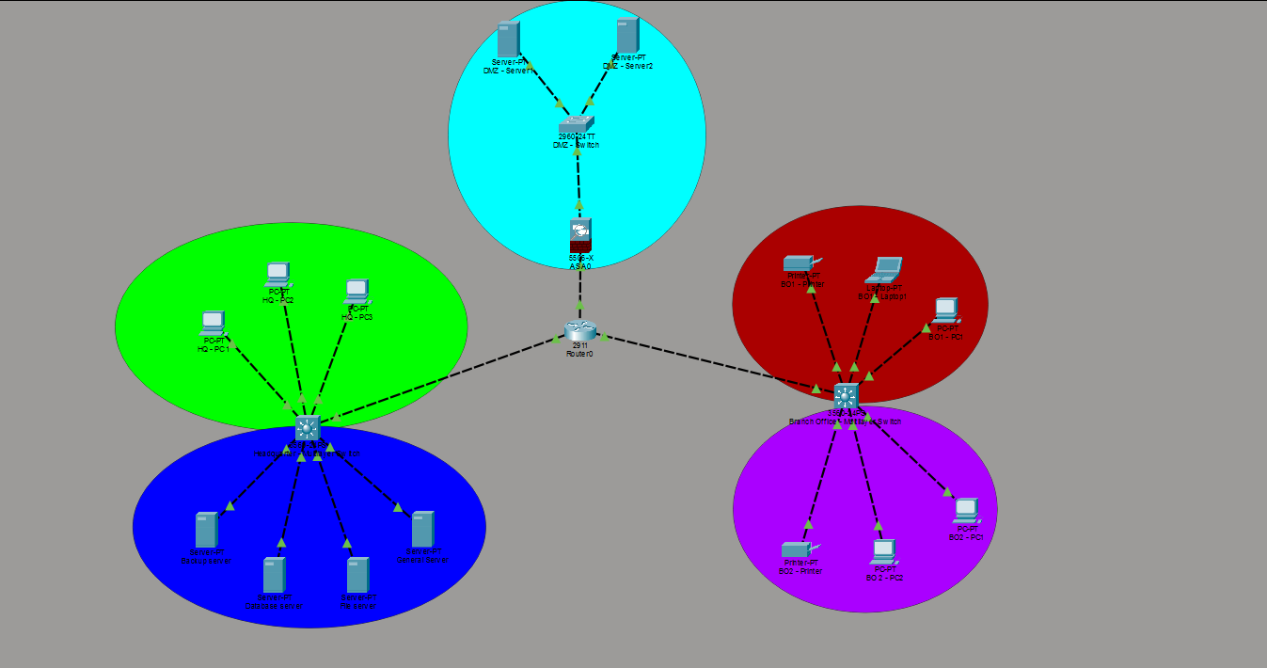Figure 1 Topology Diagram.
Headquarters (HQ) - Green
Data Center (DC) - Blue
Branch Office 1 - Red
Branch Office 2 - Purple
DMZ - Ciano

IP Addressing & VLAN Assignments
To ensure logical isolation and security, the following VLSM-based addressing scheme was implemented:
Segment | VLAN | Network Address | Default Gateway
Headquarters (HQ) | 10 | 192.168.10.0/24 | 192.168.10.1
Data Center (DC) | 20 | 192.168.20.0/24 | 192.168.20.1
Branch Office 1 | 30 | 192.168.30.0/24 | 192.168.30.1
Branch Office 2 | 40 | 192.168.40.0/24 | 192.168.40.1
DMZ | 50 | 192.168.50.0/24 | 192.168.50.1

Routing Protocol Configuration
Interface Status
To verify the physical and logical status of the core router, the show ip interface brief command was used.
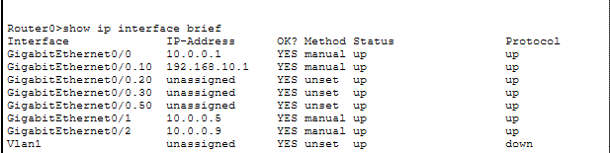Figure 2: Command show ip interface brief.
OSPF Implementation
OSPF was configured to advertise all internal networks. It allows dynamic path discovery and ensures that if one link fails, the network can converge on an alternate path.
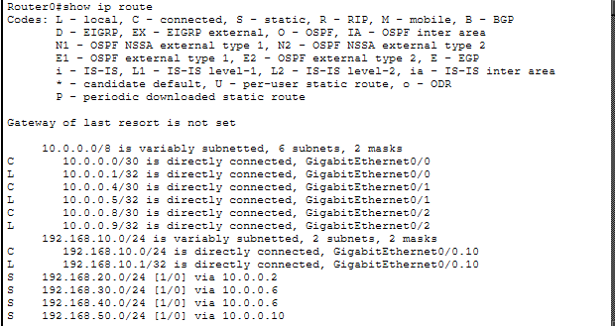Figure 3: Shows the ip route.
From the routing table presented above, it can be noted that the routes having the symbol “O” at their beginning are clear proof that the OSPF protocol is efficiently communicating network topology information between the Headquarters and the Branch offices. The Administrative Distance of 110 represents a regular OSPF route.

Network Connectivity Verification
To demonstrate that the infrastructure is fully operational and that the routing protocols and security policies are correctly implemented, the following ten connectivity ping tests were performed.
Test ID | Source Device | Destination Device | Command | Objective
T-01 | HQ-PC1 | HQ Default Gateway | ping 192.168.10.1 | Validate Local VLAN 10 & Sub-interface functionality.
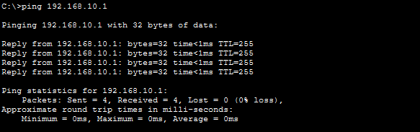Figure 4 shows a successful ping command.
T-02 | HQ-PC1 | DC-Server1 | ping 192.168.20.11 | Verify Inter-VLAN Routing from HQ to Data Center.
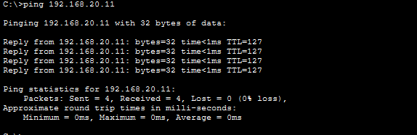Figure 5 shows a successful ping command.
T-03 | HQ-PC1 | DMZ-Server1 | ping 192.168.50.11 | Validate access to the DMZ via the ASA Firewall.
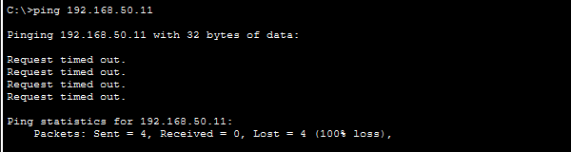Figure 6 shows a ping command testing firewall rule.
The rule created inside the ASA0 block any unauthorized connection from outside to DMZ.
T-04 | BO1-PC1 | DC-Server2 | ping 192.168.20.12 | Verify Branch 1 access to centralized Data Center resources.
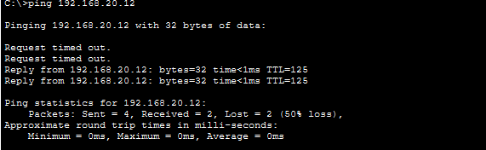Figure 7 shows a successful ping command.

T-05 | BO1-PC1 | BO2-PC1 | ping 192.168.40.11 | Confirm end-to-end routing between Branch 1 and Branch 2.
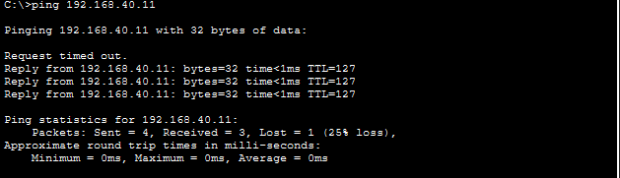Figure 8 shows a successful ping command.
T-06 | BO2-PC1 | BO2 Default Gateway | ping 192.168.40.1 | Validate Local VLAN 40 connectivity in the remote branch.
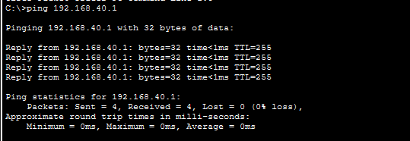
Figure 9 shows a successful ping command.
T-07 | DMZ-Server2 | DMZ Gateway | ping 192.168.50.1 | Verify DMZ segment interface on the Security Appliance.
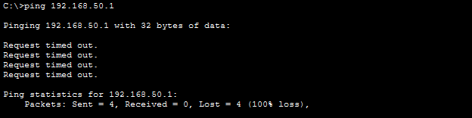Figure 10 shows a failed ping command.
T-08 | BO1-Laptop1 | HQ-PC2 | ping 192.168.10.12 | Verify Branch-to-Headquarters connectivity over the WAN.
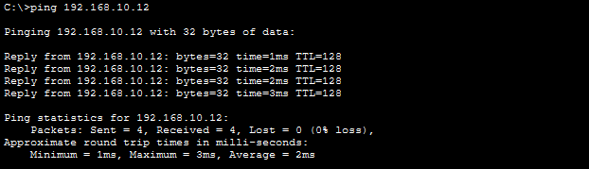Figure 11 shows a successful ping command.
T-09 | HQ-PC3 | BO2-PC2 | ping 192.168.40.12 | Confirm HQ management access to Branch 2 workstations.
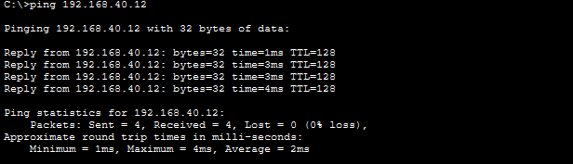Figure 12 shows a successful ping command.
T-10 | DMZ-Server1 | DC-Server1 | ping 192.168.20.11 | Security Test: Verify ACL 110 blocks DMZ-to-DC traffic.
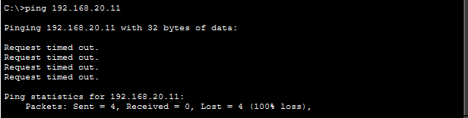Figure 13 shows a failed ping command.
The ping from the DMZ-Server1 to the Data Center resulted in a 100% packet loss. This is the expected of a silent drop policy enforced by the Access Control List or the ASA Firewall. By not returning an 'Unreachable' message, the network hides its internal structure from potential attackers in the DMZ, effectively mitigating reconnaissance threats.

Security Policy Implementation
Each network segment employs specific security controls via extended ACLs.
Headquarters & Data Center (ACL 100/110)
- Policy: Only internal authorized subnets can reach the Data Center. External DMZ traffic is strictly denied.
- Command: access-list 110 permit ip 192.168.10.0 0.0.0.255 192.168.20.0 0.0.0.255
- Command: access-list 110 deny ip 192.168.50.0 0.0.0.255 192.168.20.0 0.0.0.255
Branch Offices (ACL 101)
- Policy: Restrict traffic to standard web protocols (HTTP/HTTPS) and DNS.
- Command: access-list 101 permit tcp 192.168.30.0 0.0.0.255 any eq 80
DMZ (ACL 120)
- Policy Analysis:
- Line 10: permit tcp any host 192.168.50.11 eq www:
This permits external users from any network to access the Web Server (192.168.50.11) specifically via the HTTP protocol (Port 80).

- Line 20: deny ip 192.168.50.0 0.0.0.255 192.168.10.0 0.0.0.255:
This is a critical security rule. It ensures that even if a server in the DMZ is compromised, it is blocked from initiating any connection to the Headquarters (192.168.10.0).

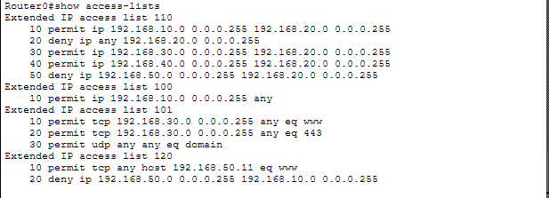

Potential Security Threats and Mitigation Strategies
Unauthorised Access
Threat
Unauthorized access is when people attempt to gain entry into a company’s network without proper authorization, resulting in stealing of information and misuse of the system.
Mitigation
Mitigation
Access Control Lists help determine who can have access to the resources of the network.
Authentication uses strong passwords and other security techniques.
Role-Based Access Control allows users to have access to only those resources required for performing their role.
Malware Propagation
Threat
Malware Propagation Malware propagation happens when malicious software spreads across company devices and branch offices, causing damage or disrupting operations.
Mitigation
VLAN segmentation divides the network into smaller sections to reduce malware spread. Endpoint protection antivirus and security software protect user devices. Patch management regular updates fix vulnerabilities in systems and software.
Denial of Service (DoS)
Threat
A DoS attack involves flooding the server or the network with too much traffic, which denies service to legitimate users.
Mitigation
Firewall filtering filters out malicious packets at the gateway itself before allowing traffic to enter the servers.
Rate limiting restricts the rate at which a server can be accessed.
DMZ segregation isolates the publicly accessible servers from the internal network.
Man-in-the-Middle Attacks
Threat
The Man-in-the-Middle attack occurs when an intruder secretly eavesdrops on communication between two machines in a network, reading, altering, or stealing the information being sent without the users' knowledge.
Mitigation
Encrypted protocols are used for secure management protocols, such as using SSH rather than Telnet.
Switch port disablement involves shutting down any ports that are not in use.
Port security ensures that only authorized devices can be connected to the switch ports.

Data Breaches
Threat
A data breach happens where sensitive or confidential information held by a company is accessed, taken, or made public through unauthorized persons.
Mitigation
Access restriction in Data Center reduces both physical and computer accesses to authorized users only.
Back-up policy refers to backup processes that help to retrieve any information that has been compromised or lost.
Monitoring and logging refers to activities aimed at detecting suspicious activities.

Conclusion
In this project, an example of how the network architecture can be designed for a multinational company in order to provide reliable communication across its different locations is shown.
With the help of appropriate routing protocols like OSPF and BGP, IP subnetting and VLAN segmentation, this network provides efficient traffic distribution, access control, protection from cyber attacks, and flexibility for further development.
The designed solution complies with the best practices used in enterprise network design and can be implemented in reality.

Reflection on Learning Experience
This project helped me understand better how enterprise networks can be designed and how to implement their security features.
I got practical experience in designing a complex network topology with the help of Cisco Packet Tracer.
I learned more about proper IP subnetting and VLAN design.
I understood how the use of dynamic routing protocols like OSPF and BGP can optimize the network operation.
I practiced with configuring ACLs and firewall policies to control network traffic flow.
The main lesson I have learned from this task is that efficient functionality and security have to be combined in the process of network management. It is risky when a network is fast but insecure and too limited when it is fully protected but poorly designed.

The most important lesson from this assignment is that network functionality and network security must be designed together. A network that is fast but insecure creates risk, while a secure but poorly designed network limits business operations. Effective network administration requires balancing both.

